Employee Volunteering Policy

October 2021 (2nd edition)

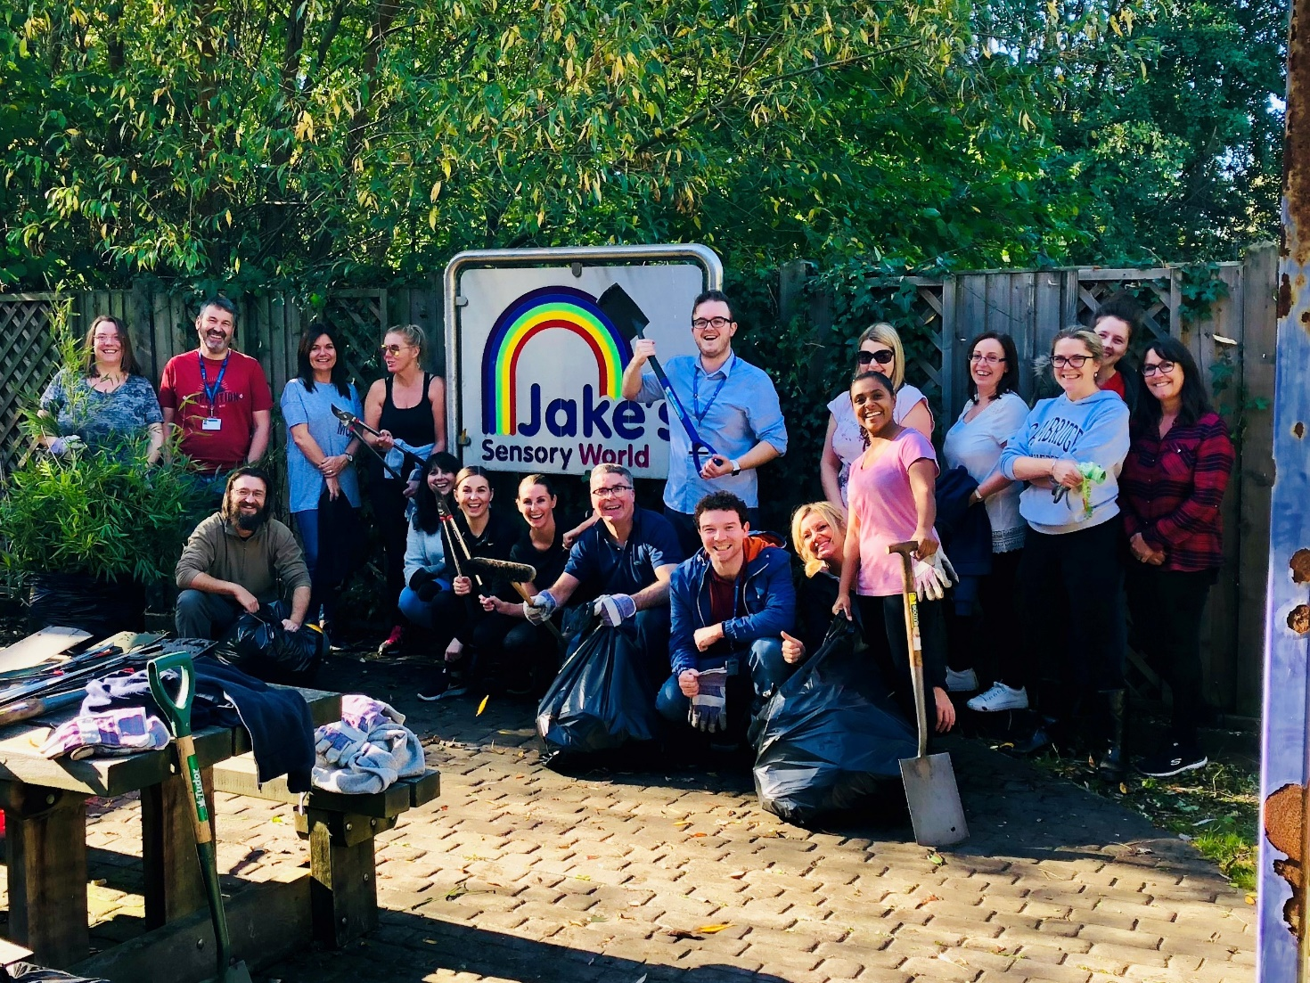

Table of Contents

Our commitment to volunteering 1
What is the Employee Volunteering Scheme? 2
The Impact of the Covid-19 Pandemic on Volunteering 2
Types of employee volunteering activity 2
Team Activities 2
Individual Activities 3
Why volunteer? 3
Benefits to employees 3
Learning new skills 3
Team building and meeting new people 3
Boosting confidence 3
Making a difference 4
Having fun 4
Benefits to the local community 4
Benefits to the Council 4
Help the local community 4
Improve local reputation 4
Build important relationships 4
Enhance the skills of employees 5
Time allowed for volunteering 5
What can I request? 5
How do I make a request for volunteering? 5
Conditions of the Employee Volunteering Scheme 6
Monitoring and evaluation 7
Health and safety 7
Insurance 8
Disclosure and Barring Service (DBS) checks 8
Scheme review 8

Our commitment to volunteering

Statement from Councillor Paulette Lappin, Cabinet Member, Regulatory, Compliance and Corporate Services and Dwayne Johnson, Chief Executive

We are delighted to support the second version of Sefton Council’s Employee Volunteering Scheme.

The scheme is designed to support those already volunteering and to encourage new people to get involved. We understand the real difference that even the smallest contribution can make and hope the scheme will help you to find your ideal volunteering opportunity.

Volunteering embraces the themes in the Sefton 2030 Vision

- together a stronger community
- a borough for everyone
- living, working and having fun
- a clean, green, beautiful borough
- visit, explore and enjoy
- on the move
- open for business
- ready for the future.

It also enforces the One Council values of

- putting people at the heart of what we do
- listening, valuing and respecting each other’s views
- developing a culture of challenge, ownership, innovation and improvement
- being ambassadors for Sefton
- being responsive and efficient
- being clear about what we can and can’t do.

As well as the chance to expand and share your skills and experience, it’s a great way of playing a more active role in society. It can broaden outlook and appreciation of diverse communities, creating a greater awareness of the needs of your community. It can improve job satisfaction, morale and personal development, and also support our staff mental health, simply be a means of giving, to create a more robust and resilient society.

What is the Employee Volunteering Scheme?

Employee volunteering is when volunteers are supported by their employer, either during work time or in their own time, to undertake volunteering activity.

Through the Scheme the Council will release employees for two days paid leave and three days unpaid leave (or pro-rata equivalent) from normal duties in a 12 month period to continue current volunteering or undertake new volunteering activities.

The Impact of the Covid-19 Pandemic on Volunteering

The Covid-19 Pandemic has had a significant impact on staff being able to volunteer in the community. However, it has also meant that many more Sefton staff volunteered outside of work that have never volunteered before in order to support their families, friends, neighbours and local communities. They did this by doing things such as collecting shopping or medications, checking that people are well and have everything that they need, cooking meals for their community, or taking part in the NHS Covid 19 volunteer scheme.

It is hoped that people will continue with this level of volunteering in the future and that the volunteering policy will support staff to do this.

Types of employee volunteering activity

There are two main types of volunteering activities:

Team Activities

A “one-off” practical task completed by a group of employees, often in one day. This offers great team building opportunities, as well as the chance to work in a One Council way with colleagues from other service areas. Employees have a day away from their usual working environment where they can develop new skills and go home with a real sense of achievement. Teams can do a half or full day activity, working on projects such as painting buildings or undertaking a community garden project.

Individual Activities

Individual activities are a great way to develop individual skills in specific areas of work and to work with different community groups.
Examples include:

- volunteering through The Duke of Edinburgh’s Award Scheme
- supporting adults at risk and those with disabilities
- reading and listening activities at schools
- organising sports activities, clubs or events
- acting as a trustee for a charity

Why volunteer?

Benefits to employees

Community involvement offers a whole range of benefits to employees including:

Learning new skills

Employee volunteering is viewed as a positive activity which contributes to an individual’s lifelong learning. It can also enable employees to develop their skills in a way not necessarily possible at work e.g. managing a project. They can learn important life and work skills from working in a new and different environment.

Team building and meeting new people

Team volunteering activities can help to both build relationships within existing teams as well as enabling employees to meet and network with colleagues from other services through the One Council ethos of cross-service team working. Volunteering can also provide networking opportunities with people working for other organisations.

Boosting confidence

Volunteers can improve their skills and self-confidence by trying new activities.

Making a difference

Volunteering will help employees to get a wider perspective of some of the issues in the local community. It also provides employees with an opportunity to contribute to an issue they really care about. It can be satisfying and fulfilling to do something that helps others.

Having fun

Most employees enjoy volunteering enormously, seeing it as an opportunity to do something completely different from their day job.

Benefits to the local community

The voluntary sector relies on outside support to meet the needs of the community it serves. Employee volunteers contribute time, skills and enthusiasm to get things done. Skilled employee volunteers can not only provide the professional skills which voluntary organisations struggle to afford, but also help the organisation’s own employees. Volunteers, in turn, develop new skills and increased confidence.

Benefits to the Council

Employee volunteering can help the Council to:

Help the local community

The Council recognises the importance of playing an active part in the local community and believes it is important for employees to get involved in community activities as a way to give something back.

Improve local reputation

Employee volunteering can attract positive media coverage, enhance the Council’s reputation and raise its profile. Employee volunteers make great ambassadors and will help make the Council an employer of choice and a great place to work.

Build important relationships

Employee volunteering will help the Council to establish beneficial relationships in the wider community.

Enhance the skills of employees

Employees have the opportunity to develop and practice a wider range of skills, especially leadership, communication, creative thinking, problem solving, decision making, project management and team working.

Time allowed for volunteering

What can I request?

Employees can take a maximum of 2 days (14.4 hours) paid leave and three days (21.6 hours) unpaid leave in any 12-month period, (part time employees will be on a pro rata basis), to carry out voluntary work. In addition, 1 day with pay will be allowed for a team volunteering activity.

The hours may be taken as a whole block of time or can be spread across the year. However, time off must be agreed in advance with the employee’s manager and will be subject to service needs. Employees can also top-up volunteering allowances with annual leave, flexi or unpaid leave if required, with manager approval.

The work time that is spent as a volunteer is in addition to any other time allowed off for public duties as specified in the Special Leave Policy.

All volunteering activities should be undertaken within Sefton boundaries to benefit our residents.

How do I make a request for volunteering?

It will be the employee’s responsibility to organise his or her own volunteering activity, whilst being supported by the Council. Employees can suggest their own ideas, choose to use their paid time off at an organisation they already volunteer for, work with local voluntary agencies who will be able to recommend activities, or take part in a team volunteering activity organised through the Council.

For information about volunteering opportunities in Sefton please visit the Sefton Volunteer Centre website https://volunteeringsefton.org.uk/

Once the employee has identified a volunteering opportunity and made contact with the voluntary organisation, they must speak to their line manager to obtain approval including any proposed dates and times, before undertaking the activity.

The manager will consider the request and then let the employee know their decision. The Council reserves the right to decline an application. Reasons could include service needs, planned structural changes etc.

The manager will record the volunteering activity on the absence feeder system and the employee should record the leave as “volunteering”. This will enable monitoring of volunteering activity throughout the Council.

Once an application has been approved, the times and dates of the volunteering activity should be agreed in conjunction with the employee’s manager and the voluntary organisation/charity.

When the volunteering activity has been completed, the organisation for which the employee has volunteered should send an e-mail confirming that it has taken place.

Conditions of the Employee Volunteering Scheme

- The volunteering activity should not bring the Council into disrepute.

- There should be no conflict of interest, such as political campaigning or acting as a treasurer for a charity that the employee has regular contact with in their Council role. Employees should seek further advice from their manager if they are concerned about potential conflicts of interest.

- As an employee of the Council it is important to adhere to the Council’s policies and procedures including the Code of Conduct. Employees must also respect confidentiality when undertaking voluntary activity.

- Employees should demonstrate the Council’s values and behaviours.

- Staff should record any time taken for voluntary activities as ““volunteering” and whether it is paid or unpaid. Time off for voluntary activities must also be recorded on the absence feeder system as “volunteering paid” or volunteering unpaid” as this will feed through to Payroll.
- Employees who accept a volunteering activity are expected to attend and meet their commitment. If an employee is unable to attend a pre-agreed volunteering activity they will need to inform the voluntary organisation as well as explain their non-attendance to their manager.

- Volunteers must not be paid, receive financial benefits or gifts by the organisation they are supporting, except for expenses incurred. Employees will not be able to claim back from the Council for any hours volunteered outside of normal working hours or any travel and subsistence incurred.

- Activities must be undertaken with organisations who deliver services that are ‘not for profit’.

- Any abuse of the scheme could result in disciplinary action in accordance with the Council’s policies

Monitoring and evaluation

Evaluation of the employee volunteering programme is vital so that we can improve and build on it. We will endeavour to continually monitor and evaluate its impact to ensure long term success.

It is the responsibility of the employee and their manager to monitor the number of volunteering hours their employees undertake.

Health and safety

It is the employee’s responsibility to satisfy themselves that the volunteering organisation’s quality assurance and health and safety policies are adequate and request sight of risk assessments if they have any concerns. The voluntary organisation will be responsible for providing any induction, health and safety or other training required in order that the volunteer can perform activities correctly and safely.

Insurance

Unless an employee is volunteering to assist an activity directly managed by the Council, no insurance cover will be afforded by the Council and employees should check arrangements with the organisation that they are supporting.

Disclosure and Barring Service (DBS) checks

Certain activities that involve working with young people or other vulnerable groups may require employees to have a DBS check. Any requirement for DBS checks will be at the cost of the voluntary organisation and in accordance with their procedures.

Scheme review

This Scheme shall be reviewed after three years or sooner, in line with legislation and best practice to reflect the best possible level of support and management.

