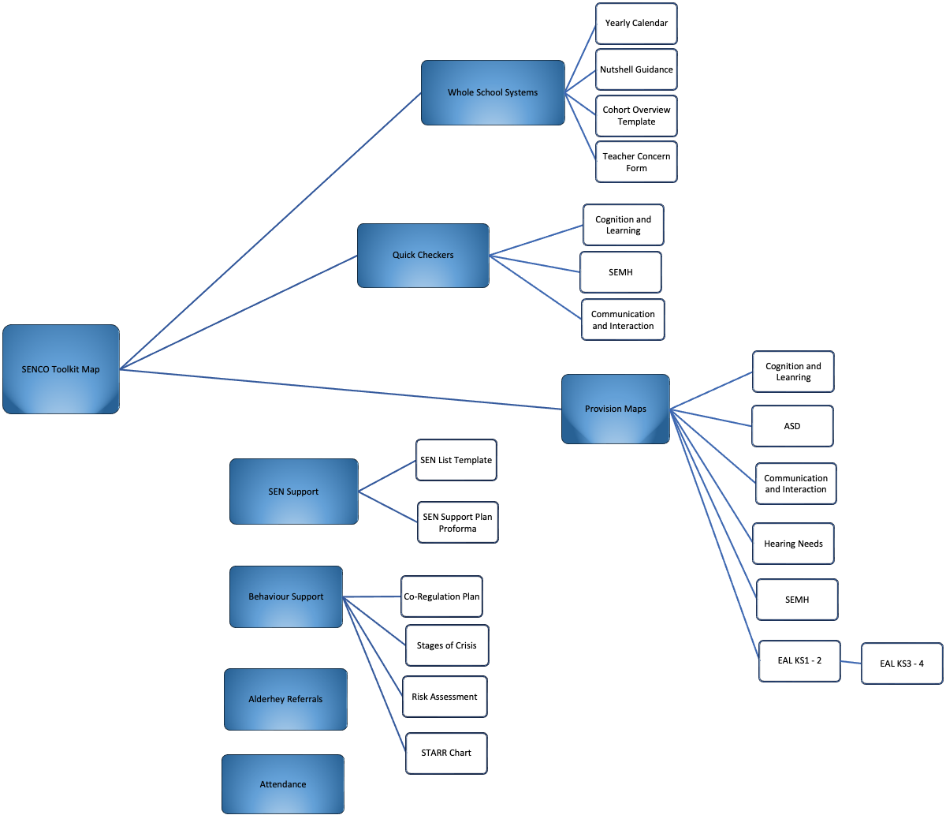
SENCO Toolkit Map
(Click on the shapes to go to the relevant page)

