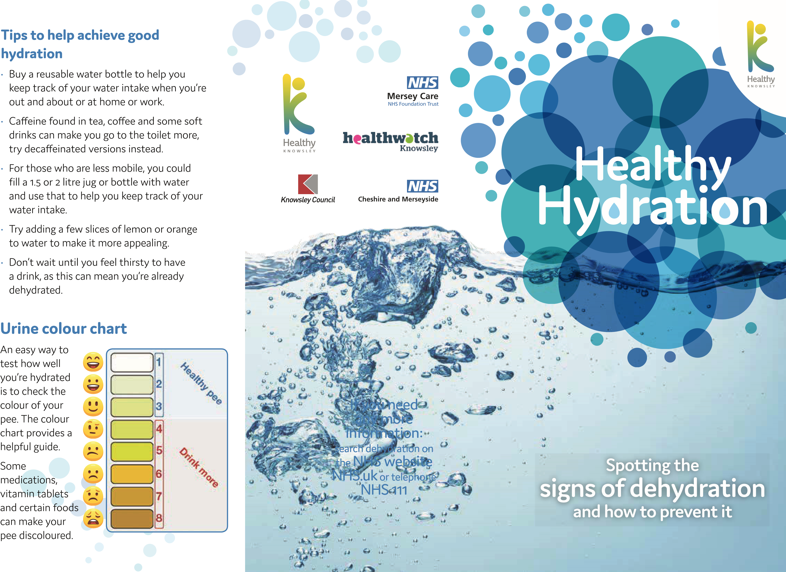

Water makes up two-

Dehydrationis caused by thirds of our body. It is essential for lubricating not drinking the joints and eyes,

enough fluidshelps with digestion, or by losing flushes out waste and

fluid and not toxins, keeps the skin replacing it. healthy and can help with concentration.

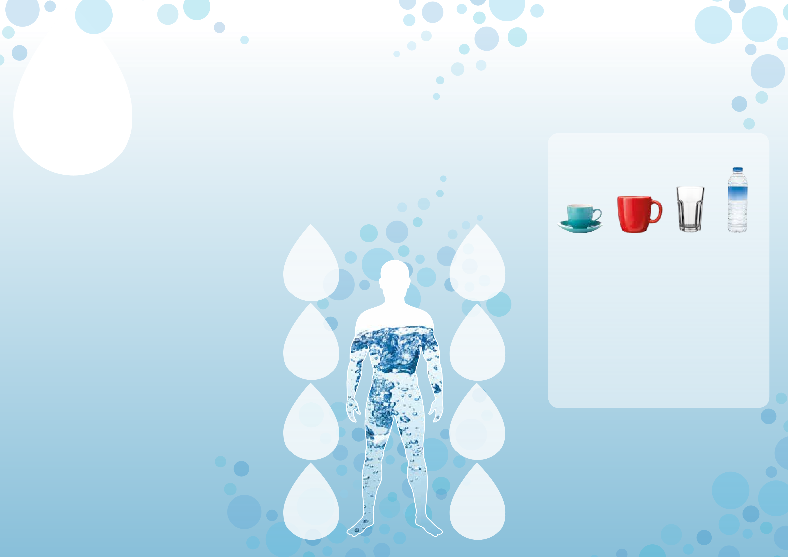Having good hydration levels can also help prevent urinary tract infections, headaches, constipation, kidney stones, poor oral health and pressure ulcers, along with dizziness and confusion which could lead to falls.

**Who is most at risk?**

You, or someone that you care for, can be at risk of dehydration if you/they:

* Are dependent on others for access to fluids or live alone
* Have swallowing problems
* Are unwell and have a raised temperature
* Have diarrhoea and/or vomiting
* Are in a very warm room or the weather is hot
* Have taken part in physical activity
* Have been drinking too much alcohol
* Limit drinks due to difficulty getting to the toilet and to reduce toilet visits during the night

Some health conditions and medications, can also increase the risk of dehydration – check with your GP or pharmacist.

# Signs of dehydration

* Feeling thirsty
* Dry mouth, lips and tongue
* Headaches and tiredness
* Sunken eyes
* Dry, inelastic skin
* Reduced ability to concentrate
* Dizziness
* Low blood pressure
* Passing small amounts of pee
* Pee that is dark, cloudy or smelly

**Dehydration can lead to:**

**Increasing Headache**

**Confusion**

**Dizziness**

**leading to Poor oral**

**Falls health**

**Urinary**

**Tract**

**Infection Constipation**

**(UTI)**

**Pressure Kidney Ulcers Stones**

# How much to drink to stay hydrated

**Aim to drink at least 1.5 to 2 litres (6 to 8 glasses/mugs) of fluid per day,** unless advised not to for medical reasons such as following a fluid restricted diet.

**How much fluid is in a measure**

**Cup Mug Glass Bottle 150ml 250ml 200ml 500ml**

**Drinking 4 bottles of 500ml of fluid is the same as 2 litres.**

**Drinking 8 glasses of 200ml of fluid is the same as 1.6 litres.**

**The amount of fluids you need can depend on how active you are, your weight, recent illness and outside temperature.**

Most fluids count (except alcohol); milk, diluted squash, fruit juice, tea or coffee, however water is best to keep you hydrated.

Some foods can also contribute towards your daily intake. For example; soup, yoghurt, milk puddings, breakfast cereals with milk and some fruit and vegetables all have a high fluid content.